**App1: lifesum**

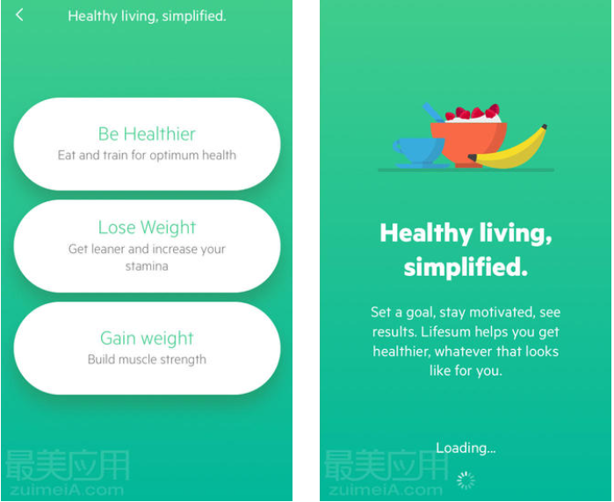

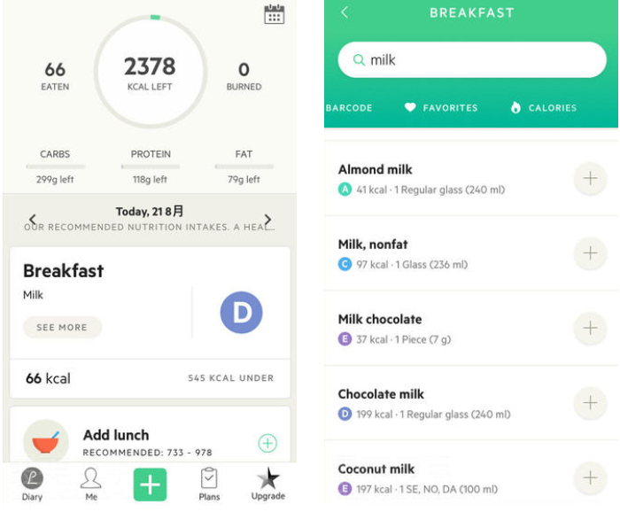

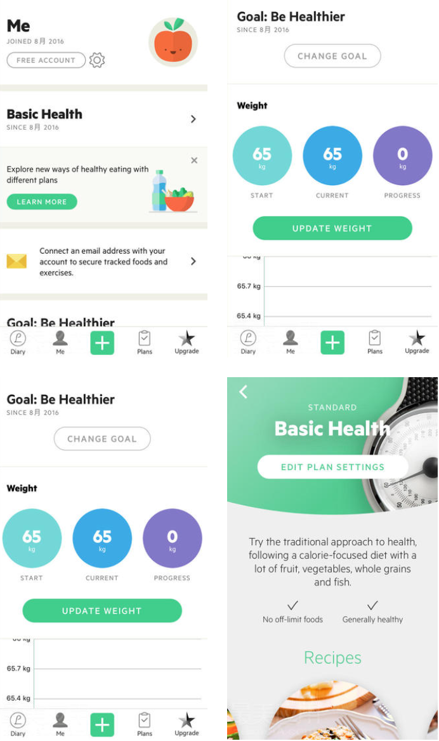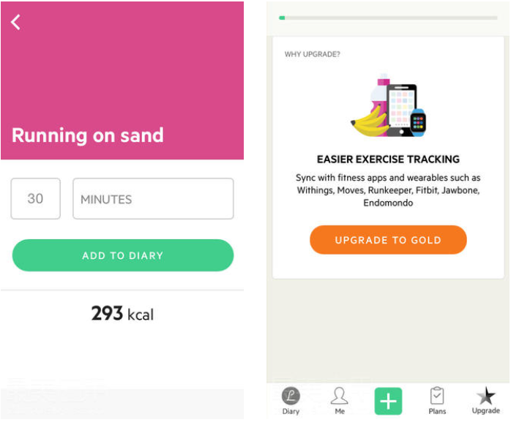

**Description of the software**

The software takes a detailed look at a user's protein, carbohydrate and fat intake and adjusts the user's nutritional intake to suit the user's personal preferences. When users want to lose weight or optimize fitness performance, the meal plans and diets in the software are suitable for any lifestyle, such as protein weight loss, Mediterranean diet, fasting, ketogenic diet, etc.

**Advantages of software**

The interface of this software is simple and beautiful. It is very simple and convenient for users to operate. It has rich and complete functions. It can provide different types of diets according to the personalized needs of different users (losing weight, gaining muscle or pursuing a healthier lifestyle). Plans and recipes.

This software also has an extremely large food database that can scan and quickly record nutritional information of food through barcode scanning.

In addition, this software can not only display the user's nutritional intake per person, but also monitor the user's exercise amount and consumption, promoting a balance between the user's energy intake and energy consumption.

The software can also summarize the user's diet and exercise information in the form of charts. Likewise, the software also has social features that allow users and friends to challenge each other, motivate and encourage each other. (Stichss, 2016)

**Disadvantages of software**

However, this software also has some shortcomings. First of all, the data of some food products in this software is not accurate or complete enough, and users must manually modify and adjust it. Secondly, some practical functions of this software require users to pay to unlock them before they can be used.

**App2: shutterbite**

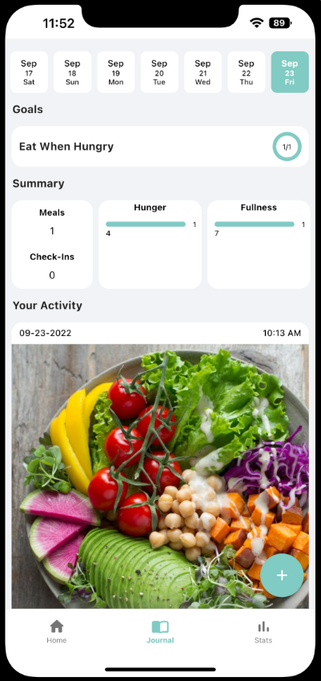

**Description of the software**

Shutterbite is a food journal app that uses an alternate approach to calorie counting. Instead of focusing on the calories that you eat we help you to find the reason. This approach to meal tracking is designed to help with issues such as emotional eating, binge eating, and mindless eating.

By becoming fully mindful and eating when you are truly hungry and also stop eating when you are full, Shutterbite helps you to build a better relationship with food.

**Advantages of software**

The advantage of this software is that it is very simple to operate and takes very little time. It only needs to use pictures to track the user's diet.

Secondly, users can choose to customize their eating records according to their own circumstances, such as the place, mood, reason, hunger and fullness when eating, etc., allowing users to more fully understand their eating motivations and results.

Users can also customize their own eating habits goals, and display their progress or trends through detailed charts and data.

Finally, this software also supports social sharing. Users can directly upload their photos and data to other platforms to communicate and interact with friends. (Appadvice, 2022)

**Disadvantages of software**

However, there are also some problems with this software. First of all, the artificial intelligence service in the software can only be used when connected to the Internet. Once the network connection is disconnected, this service will not be available.

Secondly, the software is free for a limited time or number of times for users to experience. Once the limit is exceeded, you need to pay to continue using it.

**Reflection and Summary**

Through the analysis of these two software, our team found that neither software has specific target users. Therefore, our team's software needs to set a specific target user.

Then, our team found that each software has personalized customization and social functions. Therefore, our team decided to allow users to customize their own recipes including the type and quantity of food. At the same time, by liking the recipes ways to increase social functionality.

**Reference**

Appadvice. (2022). Retrieved from https://appadvice.com/app/shutterbite-mindful-eating/1592843782

Stichss. (2016). Lifesum. Retrieved from http://zuimeia.com/app/4384/